### **Real Estate Listings and Analytics**

**Internship Data Analytics Project  
Name**: Anjana B. Nair  
**Tools Used**: PostgreSQL, DBeaver, Power BI

### **1. Introduction**

In a competitive and dynamic real estate industry, understanding pricing trends, regional demand, and sales performance is critical. This project focuses on analyzing real estate property listings and transaction data to uncover key insights such as average pricing by city, agent performance, and market demand in different locations.

### **2. Objective**

To design a database-driven analytics system that:

* Stores property, agent, buyer, and transaction details
* Tracks real estate transactions and listings
* Extracts meaningful business insights
* Visualizes trends and patterns using Power BI

### **3. Tools & Technologies**

| **Tool** | **Purpose** |
| --- | --- |
| **PostgreSQL** | Backend database |
| **DBeaver** | SQL IDE to create schema and run queries |
| **Power BI Desktop** | Data visualization and dashboard creation |
| **SQL** | Data modeling, joins, window functions, aggregation |

### **4. Database Schema**

* Properties: All property listings (location, price, date)
* Agents: Real estate agents managing listings
* Buyers: Buyer details
* Transactions: Links buyers, properties, and agents on sales

Relationships were defined using foreign keys to ensure data integrity.

### **5. Analytics and Insights**

A series of SQL queries were executed to extract the following insights:

| **Insight** | **Method** |
| --- | --- |
| **Avg. Price by City** | Group by city with AVG() |
| **Monthly Price Trend** | Window functions and TO_CHAR(date) |
| **Top five (5) Expensive Listings** | Ordered by price |
| **Unsold Properties** | LEFT JOIN where no matching transaction |
| **Agent Leaderboard** | Aggregate sales and revenue per agent |
| **High-Demand Areas** | Count of transactions by location |

These queries were exported to CSV and visualized in Power BI.

### **6. Dashboard Highlights**

| **Visualization** | **Description** |
| --- | --- |
| Bar Chart | Average Price by City |
| Column Chart | Monthly Price Trend |
| Table | Top 5 Expensive Properties |
| Line Chart | Unsold Properties |
| Area Chart | High-Demand Areas |

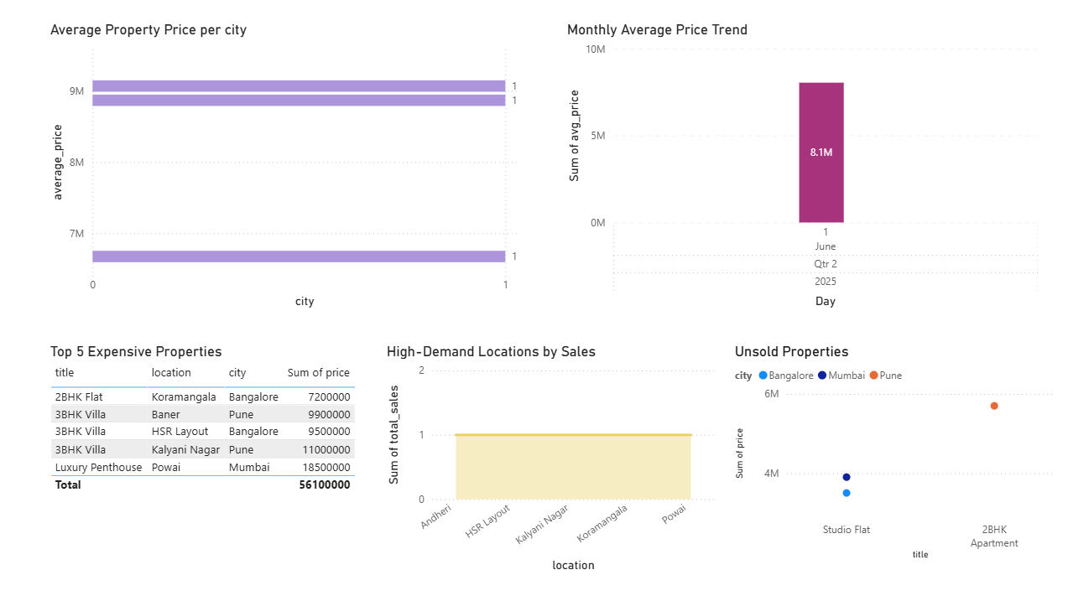

### **7. Outcome & Learning**

This project provided hands-on experience in:

* SQL data modeling and queries
* Real-world data simulation
* Power BI dashboard design
* Business storytelling using data

The dashboard offers a compact view of market conditions and can help real estate firms make informed decisions.

### 

### 

### **8. Conclusion**

This internship project helped bridge the gap between data engineering and data visualization. It demonstrates how raw business data can be transformed into actionable insights using SQL and BI tools — a key skill in today’s data-driven job market.